The Project

Given rough guidelines, our task was to create a web-based trading game that uses PostgreSQL a database to maintain the game’s state. The guidelines were not strict, with the emphasis being more on creating an enjoyable, playable game for the average computer user.

Choice of implementation language

Our first decision was which server-side scripting language to use. Possible candidates supported by the department’s servers were:

- CGI/Perl – Though powerful, rather old and one of the aims of this project was to broaden our range of skills with modern languages.
- ASP – Discouraged by the department in a previous project and thus never seriously considered.
- JSP – Powerful range of features such as javabeans and servlets, but possible Tomcat server problems in the department made this an unlikely choice.
- PHP – simple and tailor-made for the purpose of this project.

Group members had previous experience with PHP, asp and JSP.

Here it seemed that PHP was the obvious choice. But when the decision had to be made, we were unsure whether its range of features would be adequate compared to JSP. It turned out not to be a problem at all.

It should be noted that PHP code had to be embedded in CGI files to work correctly. However, to avoid possible confusion with CGI/Perl, we refer to the files simply as ‘PHP’ files in this report.

Structure of the Program

Up to 30 players could play at a time, in one common game.

Each player owns one and only one planet, which falls under one of three civilisation categories: agricultural, industrial and mining. The planet’s type determines what type of activities can take place on the planet. These activities require resources as input and generate other resources as output, which can be used directly or sold to other players to generate income. The way in which the transactions work is explained in greater detail below.

The player who has the highest income is winning. However, the game continues indefinitely and thus there is no terminal winner. The only scenario in which a player could ‘lose’ is to have no money or resources to make any transactions. At that point, the player has no alternative but to delete its account.

This structure has some major differences to those suggested in the specifications. Below we outline our reasons for structuring the game in the way we did, as opposed to these specifications.

How and Why we changed the suggested structure

The typical game structure was based on turns and direct negotiation between users to buy goods.

It was an unsatisfactory structure because, although it ensured fairness, its playability was compromised. These features were discarded very early in the design process and a new structure was pursued.

We did not implement a turn-based game. This was because it was felt that:
- The time spent waiting for other players to make moves would become intolerable for games of more than, say, 3 people.
- That would be unless the time allocated per move was minimal. This too is undesirable as the player might make irrational decisions under time constraints.

Also, we decided not to enforce direct communication between players when purchasing items for similar reasons relating to time spent waiting for the other player to respond.

Put quite simply, we wanted players to be able act whenever they wanted with no restrictions. This meant being able to buy any goods that had been put for sale at any point.

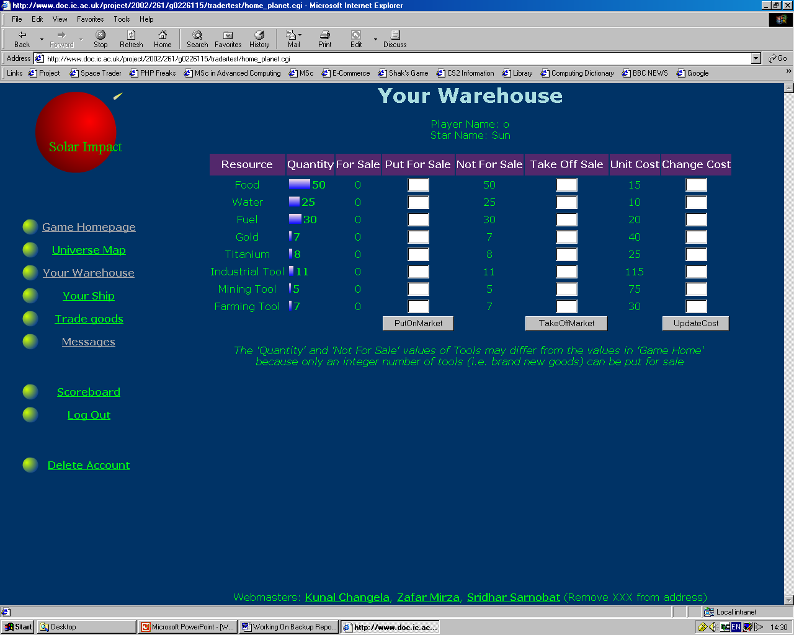

With no turns, we had to find an alternative means for regulating the production of goods and deterioration of machines (the turns would have an implicit time model).
- The deterioration of machines is proportional to its usage rather than number of turns made by the player.
- Goods are only produced when the player chooses (by clicking on the appropriate buttons).

Why we chose to have just one ‘Master’ game
Having many separate games, we felt, was cumbersome from an implementation point of view but, more importantly, unnecessary. Surely a game would be more enjoyable when there are more players to trade with? Therefore, rather than have, say, 10 games each with 2 players we should have a 1 game with 20 players.

User Interface

The essential components are summarised in the following diagram.
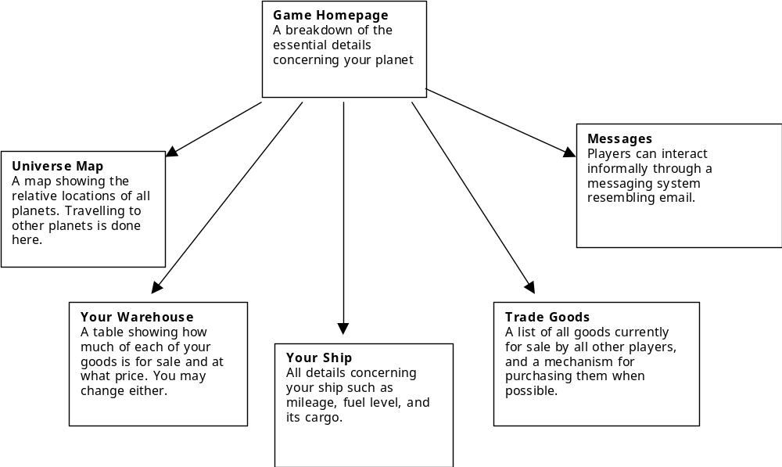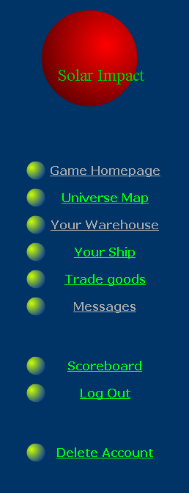

Figure 1: The User Interface

How to Play

Joining the game
- If you haven’t played the game before, see the registering section.
- If you have registered, log in and carry out your buying or selling actions.

Registration

Choose a username which is easy to remember.
- Choose a password that you don’t use on other websites as they are not stored in encrypted form. Confirm your password by typing it again.
- Supply a valid email address. We only use this for reminding you of forgotten usernames and passwords, and at no point is it disclosed to anyone else.
- Choose a name for your spaceship and select which solar system you would like to take over. The names displayed are the star names, and each has a single inhabitable planet. This planet is one of the 3 civilizations mentioned earlier.
- Confirm.

Buying goods
- Go to ‘Universe Map’.
- Place your mouse over one of the planets which isn’t yours. If it shows that any goods are for sale and you’d like to buy them, click on the planet to travel there.
- When your ship lands on that planet, you will be taken to the ‘Trade Goods’ page. Quantity boxes appear wherever it is possible to buy a resource. Type in how much of it you would like to buy. If it is possible, the transaction completes. Otherwise, you are told why it isn’t.
- Check ‘Your Ship’ to see whether the goods you bought have been loaded into your cargo hold.
- If you are ready to return home, go back to ‘Universe Map’ and click on ‘Back Home’ at the bottom of the page.
- When you’ve returned home, go to ‘Your Ship’ and click ‘Unload Cargo’.
- Go to ‘Your Warehouse’ to check that your resource count(s) have just increased.

Creating goods
- Go to ‘Game Homepage’.
- Check the tables to see if you have enough raw materials and machinery required to produce anything.
- If so, click on one of the buttons at the bottom of the page to extract titanium, grow food etc.
- Check that your resource levels have changed.

If you run out of fuel or mileage
- If you are unable to travel to another planet or back home because your ship has run out of fuel, you will need to refill the tank.
- If your ship’s mileage is too low, your ship will need reservicing.
- For either, go to ‘Your Ship’

Selling goods
- Go to ‘Your Warehouse’
- In the ‘Put for Sale’ box, enter the quantity you wish to put on the market.
- Other people should now be able to buy your goods automatically.

You may announce the release of your goods for sale through the messaging system.

Implementation overview

There are 3 types of PHP files, each of which has slightly different but important features.

- Display files are responsible for generating html code, normally through reading a database table and displaying it in a convenient form for the player. All the files in the user interface diagram above are display files.
- Data modification files update the database having been passed the relevant parameters they need (e.g. through a form from a display file). They should be transparent to the user. For this reason, they normally have a meta-refresh tag, which forwards the user on to another display file once the file has performed its modifications.
- Included files may do either of the above, but their most important feature is that they don’t need to need the right extensions or any imported libraries as they can only exist within another page. They are encouraged as they provide increased modularity and thus make code look simpler (e.g. including a menu in many of the pages). Their capabilities can also be re-used (e.g. distance calculation file).

The goods quantities represent the condition of the tools and thus need to be real numbers, not integers (though the player usually sees the floor of these real numbers). For example, a player could have 1 agricultural tool. After a certain amount of food x has been produced the tool no longer works (i.e. you have 0 agricultural tools left once you’ve produced x amount of food). But say only a half of this amount of food has been produced. The deterioration of the machine would be modelled by reducing the total number of agricultural tools to 0.5 .
Spaceship deterioration is modelled similarly, but the mileage stores the condition of the ship. Note that here mileage is a decreasing figure and when it reaches zero the ship isn’t usable. A player must now pay for the ship to be serviced, after which the ship is again usable. This amounts to ‘buying mileage’, which is simple for the player to comprehend.

One of the first considerations was whether mutual exclusion would be a problem. Unlike a turn-based game, it isn’t implicitly managed. Providing simple lock variables would only decrease the chance of race conditions rather than eliminate it completely. Implementing a semaphore or some other reliable locking mechanism is itself a considerably large task.
After careful consideration, it was decided that on a game where race conditions are unlikely that this wasn’t a priority. Thus it was not implemented. In a larger scale game, we would have to treat this issue more seriously.
Graphical representation was needed to aid player’s interpretation of the data. Most were implemented as images of appropriate width, simulating bar charts. Pictures of the resources were also included for the player, to reduce interpretation time (“Recognise rather recall” is a recommended approach to user interface design).

The Universe Map also summarised the planetary locations in a form the user can quickly digest.

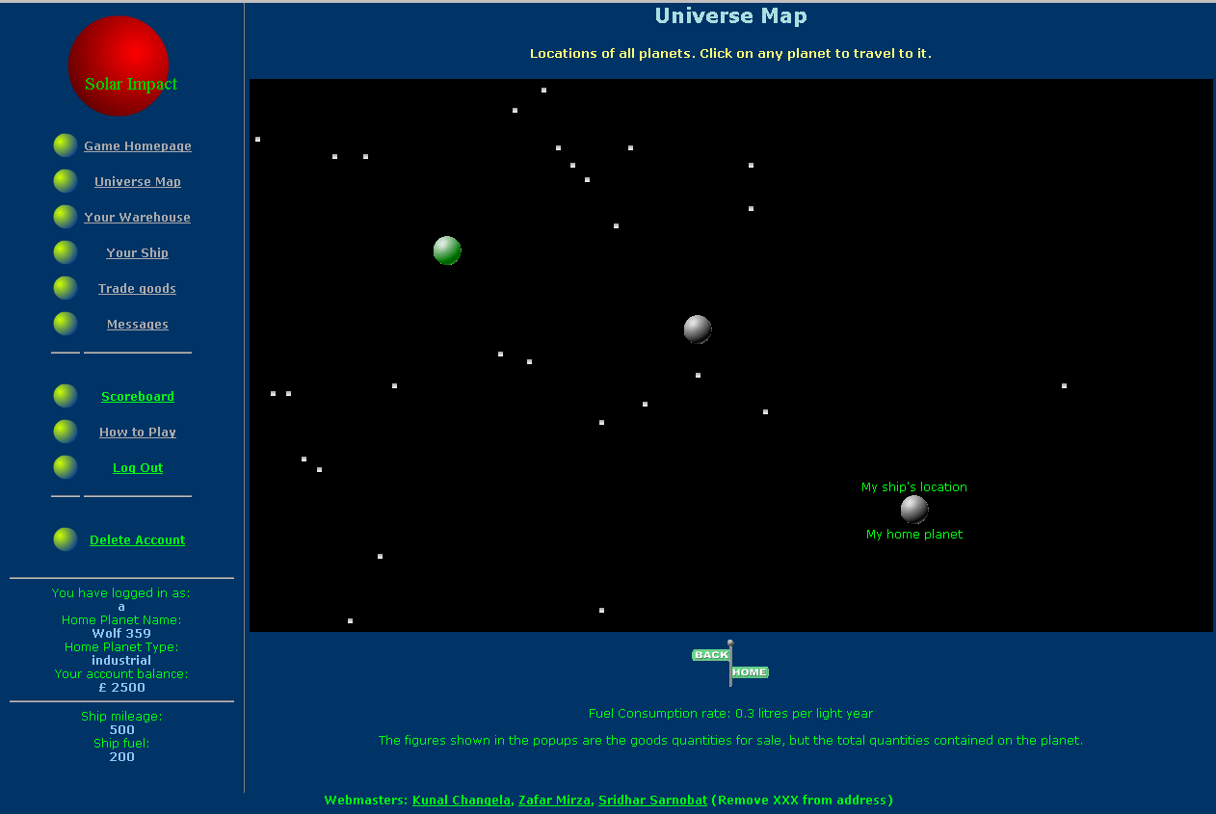

Conclusion

What we’ve learned

There were some programming mechanisms whose exact details we had previously overlooked. Once we encountered problems in running our code, we had to understand the exact operation of these mechanisms to solve our problems.

For example, we believed cookies were essentially global variables that were readable immediately after being set. This isn’t the case. When they are set, their values only propagate to the user’s system when the server reply is sent to the client. Thus the values read by a script being run will be from the cookies existing on the client’s side at the point the header request was sent. In simple terms, you cannot set a cookie and read the updated value in the same script.

Also, when embedding PHP code in CGI files, the script won’t be run successfully if the file uses DOS-whitespace encoding. These whitespace characters (linefeed, carriage return etc.) must be encoded in UNIX format.

It was the first time we had used a weakly-typed language (PHP) extensively. While its tolerance of unusually structured code is appreciated, it can fail to sport simple errors which could escalate into serious debugging problems.

We were keen to learn new skills during this project, and designing Macromedia Flash animations was one of them. We used it for displaying actions such as growing food, travelling to another planet etc. .

EXTENSIONS TO PROJECT

The main criticism of our approach was that, despite group members communicating frequently and at length, there was code from different members doing similar tasks appearing several times. Whenever this happens, good programming practice is to minimize repetition.

For example, several times the following code pattern appeared.

$sql = “SELECT * FROM …”
$resultset = pg_query(..)

We could have made greater use of functions to internally handle the execution of these queries, returning the resultset to the user. Similarly, we found that we were running the same sequence of queries to get one piece of information given another. For example, given the ‘playernum’ we had to go through a sequence of queries to obtain player’s ‘starname’. Using functions, one should be able to define the sequence of queries once and simply call the function with the ‘playernum’ as the argument and obtain the ‘starname’.

On a related point, many files became very long (e.g. trading.cgi). Though it is difficult to give specific examples, we immediately consider whether the tasks within those files could have been separated into modules of their own, making code for other group members easier to understand.

Also, regarding repetition, constants such as the ship’s fuel tank capacity, default mileage etc. should ideally be declared once and only once in a header file and used in any file.

Another issue is that of scalability: suppose the game was to be updated so there are more resource types. This might involve much altering several files to take this into account. Ideally we should only have to make changes to an array of resource types declared in the header and the game should still work as intended but with the greater range of resources. i.e. the change should only be required in one location, and filter through the entire game.

Our original for the use of Macromedia Flash were more ambitious: we wanted to display database contents in flash (e.g. fuel amount, universe map) in addition to providing user interaction through clickable Flash animations. None of us had previous experience with Flash, and so it would have required more learning time (knowledge of actionscript is also required to do this). However, we hope to learn more about it in the future.

Further Extensions:

- Countdown to end of game – at end of game, player with highest balance WINS!!!!

- We would also have liked to make use of VRML, as it is a 3D display, whereas our Universe Map only displays spatial relationships in 2 dimensions.

- Formal system to allow players to make bids for items. The owner can then choose the highest bid

- On Warehouse – button ‘Put all items for sale’ - Requires less effort from player to perform this operation

- In the Goods Trading page, calculate the subtotal automatically

- END OF REPORT -

